Migration Patterns for Data Visualization

Jake Nylund

**PROJECT OVERVIEW**

In order to put into practice what I am learning in a data visualization class I’m taking, I wanted to develop a project with potentially real world implications. Combining my some of my personal interests with publicly available datasets, I decided to investigate the migration patterns of various species of birds in North America.

Bird hits are a real problem for the FAA, and theoretically is something that may be an even bigger problem for the burgeoning drone technology. Using datasets from ebird.org and <http://wildlife.faa.gov/> and other related information, I hope to answer a number of questions regarding migration patterns. Ultimately, I would like to animate this data to show how populations change and move over the course of time.

**QUESTIONS TO ANSWER**

The following list may grow as I examine the data further and discover other questions that may be relevant to a drone flight, or are just interesting in relation to bird flight.

1. What are the highest density bird areas? (Planning to begin with Oregon data, and expand to other geos later.)
2. When are those areas more or less populated?
3. What types of species will be found in these areas? (Size of birds may have an impact)
4. What is a typical flight path and elevation?
5. Is the a correlation between predicted bird paths and aircraft collisions and could we predict the most likely collision place and time?

**TECHNOLOGY**

This is designed to be a demo, and as such it will be run locally using Python SimpleHTTPServer to host. The bulk of the work with be done with JavaScript libraries D3.js and leaflet.js. Samples shown below.

**PHASES:**

**1 – North America with limited number of species. (10 species with the most data points)**

**2 – North America with all species from EBird data.**

**3 – North and South America with all birds**

**4 – Add Europe**

**5 – Add Africa**

**6 – Add Asia**

**7 – Add Australia, Arctic and Antarctic**

**8 – Elevation Data for North America (other countries to follow in similar pattern)**

**SAMPLE GRAPHS:**

What paths are they taking and when will they be in an area?

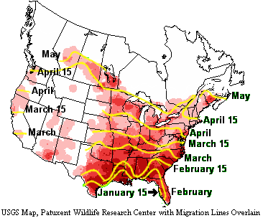

<https://encrypted-tbn2.gstatic.com/images?q=tbn:ANd9GcRKNTXPUyHIhbGs4SKVpJSwWzKfV5nM55JVl85D8owtKwJtgWnk>

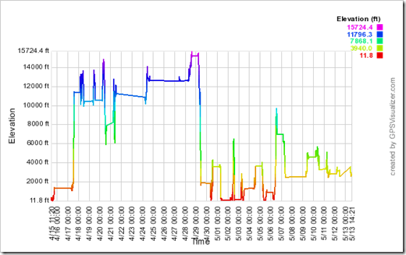<http://lh5.ggpht.com/_rWRhetumRmg/TdBI0dCHuiI/AAAAAAAACKU/SdR5rLXHckI/elevation-04-15-to-05-13_thumb%5B3%5D.png?imgmax=800>

Updates:

3/30/15: I’ve spent the past week learning more about D3 and Leaflet. I’ve got a sample of Leaflet on a custom North America map. I also got a few tips and tricks books that will hopefully make the rest a little easier.